APL LED PL LAMP GUIDE
please ensure the control gear is bypassed and the product is fed the 240v supply only , failure to bypass the control gear will cause instant failure of the LED components and render the warranty invalid
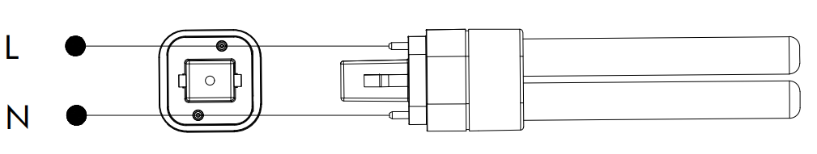PLC TYPE 2 PIN 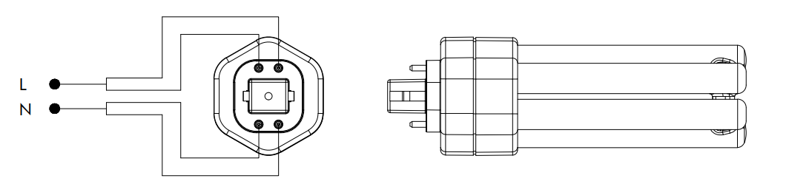PLL TYPE 4 PIN 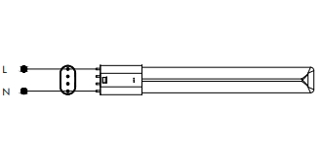PLL TYPE 4 PIN
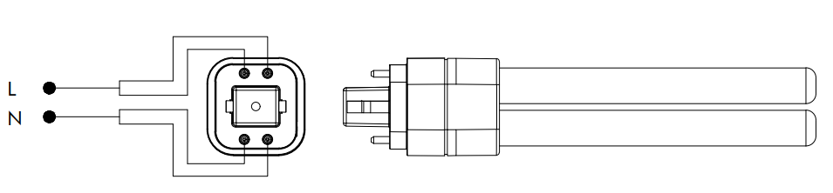 PLC TYPE 4 PIN

